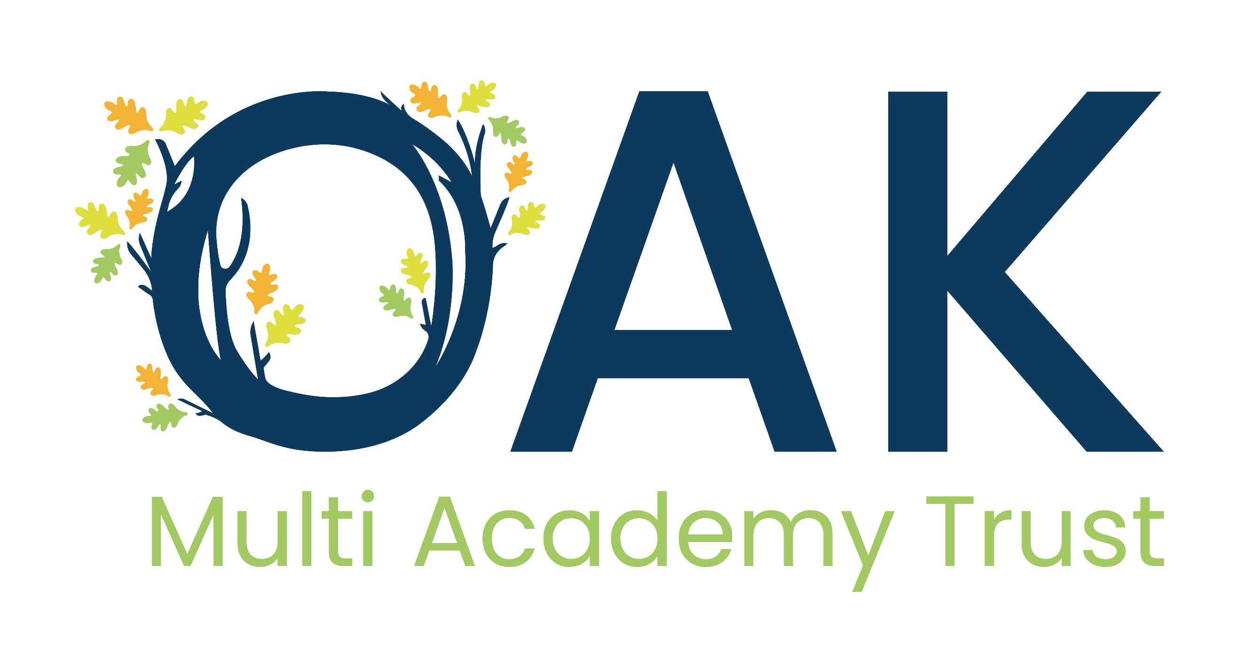

Subject Access request Form
Please return this form to the relevant school office

You should complete this form if you want us to supply you with a copy of any personal data we hold about you or the person for whom you are making this request. You are currently entitled to receive this information under the Data Protection Act 2018 (DPA) and the UK General Data Protection Regulation (GDPR).

We will also provide you with information about any processing of your personal data that is being carried out, the retention periods which apply to your personal data, and any rights to rectification, erasure, or restriction of processing that may exist.

By law, information will be disclosed to you within one calendar month of receipt of your request. In some circumstances, this timeframe can be extended up to a further two months. If this applies in your case, you will be informed within the first calendar month.

There are some occasions when we will seek further clarification from you to enable us to comply with your request. Where this is the case, the calendar month timeframe is paused until clarification has been received.

The information you supply in this form will only be used for the purposes of identifying the personal data you are requesting and responding to your request. You are not obliged to complete this form to make a request but doing so will make it easier for us to process your request quickly.

The person who the personal data is about is known as the data subject and the person who is making the request is known as the applicant. These can of course be the same person depending on the personal data sought. If you are a parent seeking access to your child’s official educational records, please contact the school office. The information you provide on this form will be used only for the purposes of processing your request.

Section 1
Name: | Surname:
Name of School
Relationship with the school

Please select:
Pupil / parent / employee / governor / volunteer

Other (please specify):

Correspondence address
Contact number
Email address
I am the data subject (please tick)

Yes (go to section 3)

No (go to section 2)

Section 2: Details of the data subject
Name: | Surname:
Address:
Date of birth:
Year group (if applicable)
Contact Number
Email

Section 3: Details of information being requested
Please provide a clear description of the information you are requesting including, dates, departments and/or any additional information which will enable us to locate it (continue on a separate sheet if needed).

Section 4: Proof of Identitiy / consent
Please send us copies of two documents that prove who you are.
€ One must be photographic (such as a valid passport or driving license) and
€ One must prove your current address (such as a recent electricity bill, or council tax bill).
Alternatively, if you are in regular contact with the school, you may wish to arrange an appointment to confirm identification in person.
However, proof of address will be required regardless unless collection of information will be in person also.
Please tick either: -
€ The information requested is about myself.
€ I am the parent / guardian requesting access to my child’s personal data.
(Please note that written consent is required if your child is the age of 13 or over.)
€ I am representing another individual
In addition to the required identification outlined above, please send us two forms of identification and written permission from the person that the information is about, saying that we can give you their information. Please note that in some circumstances we may need to verify authenticity.

Section 6: office use only
Receipt Date: |  | Received by:
ID required/received: |  | Proof of address required/received:
Reference: |  | Oak Trust informed:

